
Computer Networks Lab_241L
UW-24-CS-BS-101
Registration NO:
Muhammad Talha_CS.3ndB
Lab Task # 12
UNIVERSITY OF WAH(UOW)

DEPARTMENT OF COMPUTER
SCIENCE

COURSE:

SUBMITTED TO:

Mr. Hassan Shafaqat
SUBMITTED BY:

Task
Adding Router to Screen
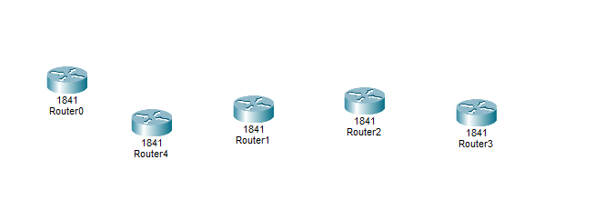
Adding Computer to Screen
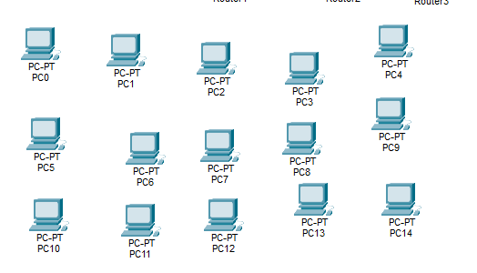
Adding Switches to Screen
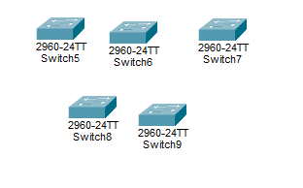

Arranging All as required and connecting according to give scienrio:
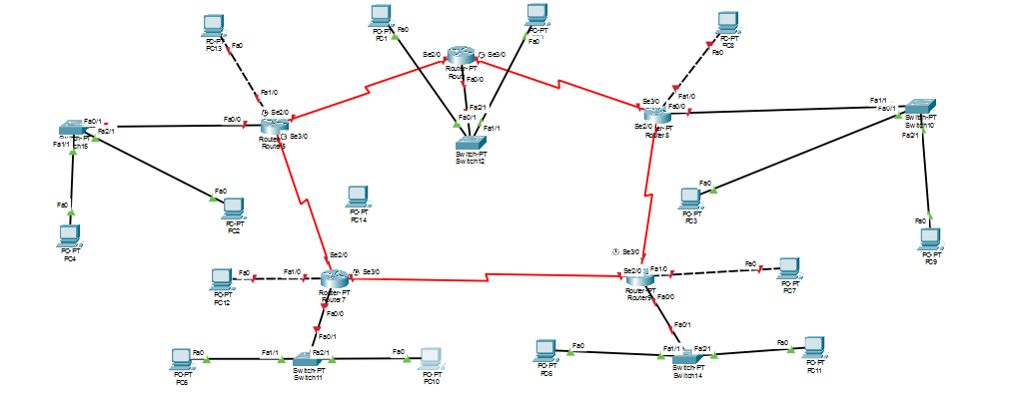
Giving IP address to all and Gateway PCs
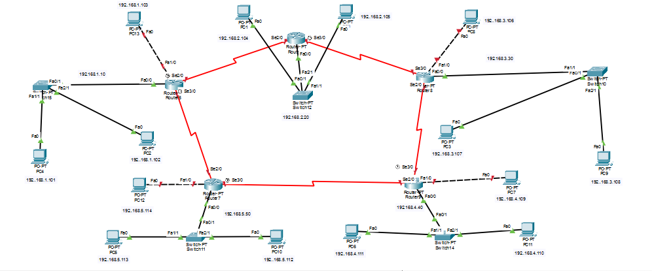
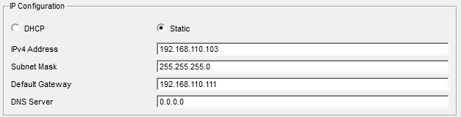
Giving Router Address
Router 1
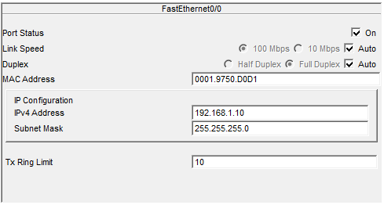
I Give to 2 serial and 2 Fast Ethnet
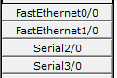
RIP
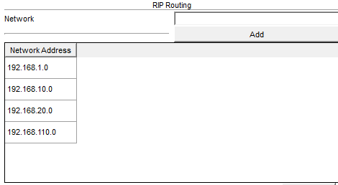
Router 2:
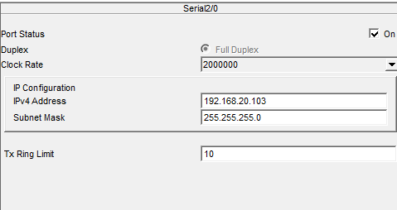
I Give to 2 serial and 2 Fast Ethnet

RIP
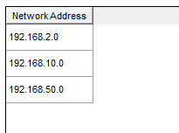

Rouer 3:
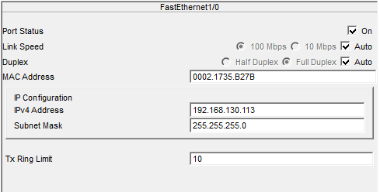
I Give to 2 serial and 2 Fast Ethnet

RIP
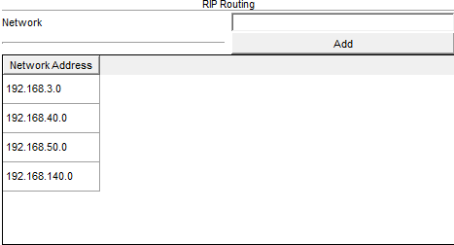
Rouer 4:
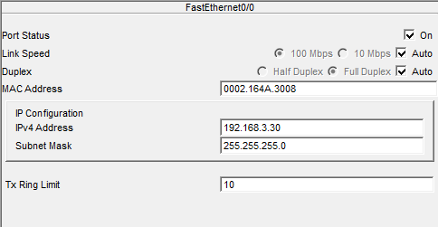

I Give to 2 serial and 2 Fast Ethnet

RIP
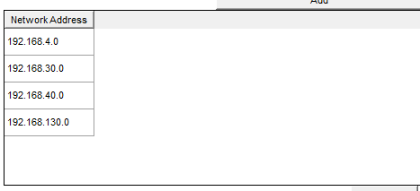
Rouer 5:
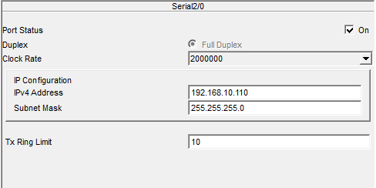
I Give to 2 serial and 2 Fast Ethnet

RIP
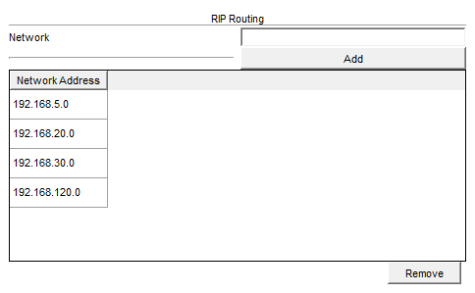

Final Structure
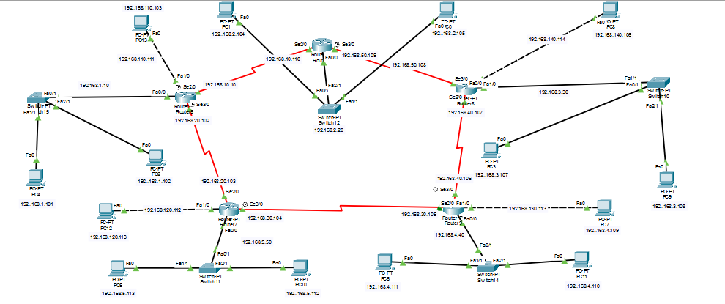
Sending Messages
From Router 1 PC1 to All:
To router 2 PC 3
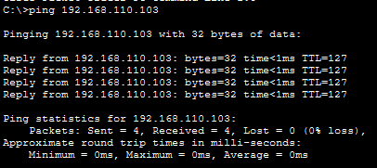
To router 3 PC 3
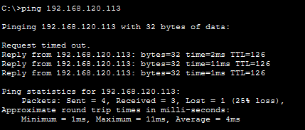
To router 4 PC 1
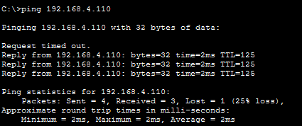

From Router 2 PC3 to All:
To router 1 PC1
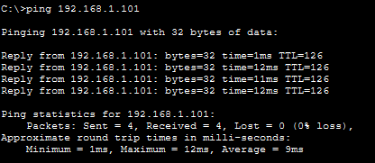
To router 2 PC2
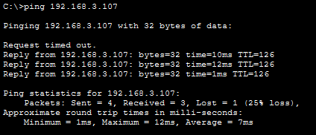
To router 3 PC1
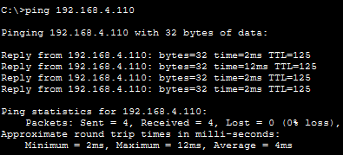
To router 4 PC1


From Router 3 PC1 to All:
To router 1 PC1
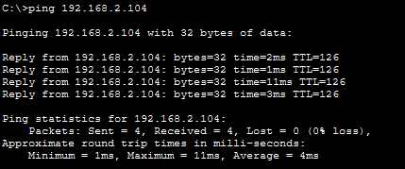
To router 2 PC3
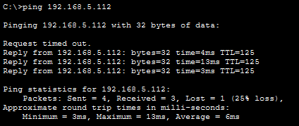
To router 1 PC1

To router 1 PC3


To router 3 PC 3

To router 3 PC 3

To router 4 PC 1


